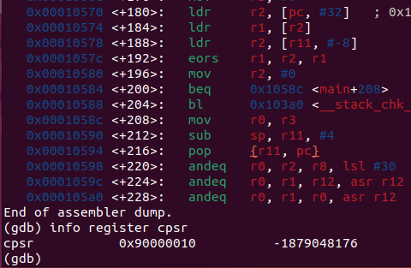
Tarun Mamillapalli
CS23B2004 1) During addition,
CPSR first bit is 9 that is 1001 so N-1 Z-0 C-0 V-1

This was taken when the number is being added.

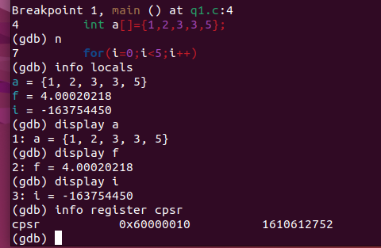

2) During conditional branch at loop entry

N-0 Z-1 C-1 V-0

This was taken when i just entered the for loop, at that point i disassembled the code;

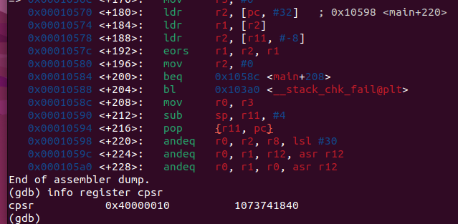

3) During conditional branch of loop exit :

N-0 Z-1 C-0 V-0

We take the first no of the cpsr content that is 4 encode into binary bits and then find out N,Z,C,V.

